Distance, Speed and Displacement Graphs
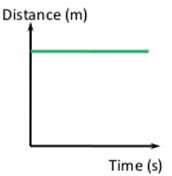
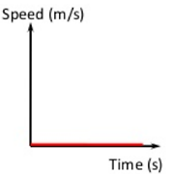
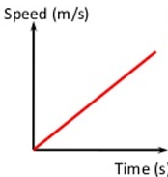
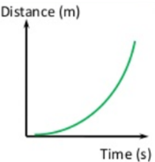
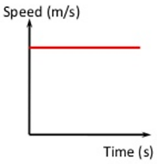
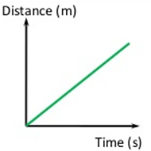
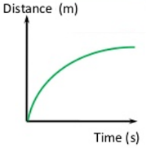
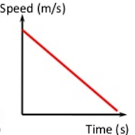
Mostly people measure the speed of an object by timing their travel over a known distance. We do this commonly with races and athletic events. Scientists tend to measure speed more closely, and graphical representations of distance versus time and speed versus time are an important part of this. Distance and speed look very different when graphed.
d) Imagine someone slowing down as they walk or drive away from you

a) Imagine a person standing stationary some distance away from you.
b) Imagine someone walking or driving away from you at a constant speed

c) Imagine someone getting faster and faster as they walk or drive away from you

Difference between DISPLACEMENT and DISTANCE
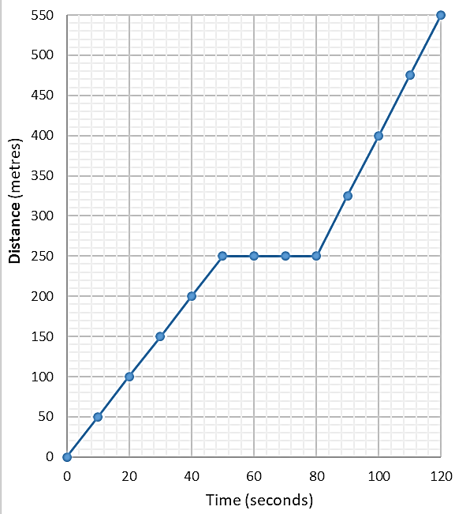
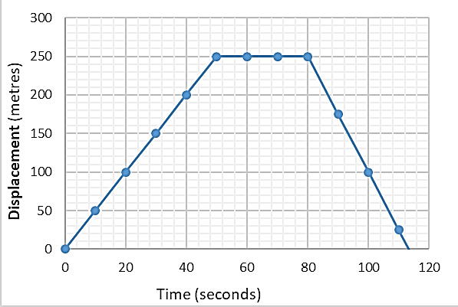
Displacement versus time graphs are similar to distance versus time graphs, EXCEPT that in displacement graphs the line can head down. This is because the person is heading back towards you. This can never happen in a distance graph as distance is cumulative and cannot get smaller, not matter what direct the person heads in.

